**WORK IMMERSION PORTFOLIO**

**Presented to the**

**Faculty of Senior High School Department**

**LIAN INSTITUTE, INC.**

**Lian, Batangas**

**In Partial Fulfillment**

**of the Requirements for Graduation in**

**SENIOR HIGH SCHOOL**

**Prepared by**

**Villaruel, Moira Ellexandia M.**

**General Academic Strand**

**APRIL 2023**

**STUDENT PARTICIPANT**

**2X2**

**PHOTO**

**PERSONAL INFORMATION**

**PERSONAL DATA**

|  |  |  |  |  |  |  |  |  |  |  |  |  |  |  |  |  |  |  |
| --- | --- | --- | --- | --- | --- | --- | --- | --- | --- | --- | --- | --- | --- | --- | --- | --- | --- | --- |
| NAME: | | Villaruel | | | | | | | Moira Ellexandia | | | | | | | | | M. |
|  | | LASTNAME | | | | | | | FIRSTNAME | | | | | | | | | M.I |
| DATE OF BIRTH: | | | | May 16, 2004 | | | | PLACE OF BIRTH: | | | | | Malaruhatan Lian, Batangas | | | | | |
| SEX: | Female | | | AGE: | 19 | | | HEIGHT: | | |  | | | WEIGHT: | | |  | |
| ADDRESS: | | | 48 Martirez St. Brgy. 4 Lian Batangas | | | | | | | | CONTACT: NO. | | | | 09922282925 | | | |
| RELIGION: | | | Catholic | | | CITIZENSHIP: | Filipino | | | | | CIVIL STATUS: | | | | Single | | |
| FATHER’S NAME: | | | | Manuel L. Villaruel | | | | | | OCCUPATION: | | | | Deceased | | | | |
| MOTHER’S NAME: | | | | Rosalyn R. Maranan | | | | | | OCCUPATION: | | | | OFW | | | | |

**HEALTH INFORMATION**

|  |  |  |  |  |
| --- | --- | --- | --- | --- |
| * Physically Fit | | * Allergy | * Medical Condition | * Undergone Surgery |
| * Others: |  | | | |

**PREFERRED COURSES IN COLLEGE**

|  |  |  |  |  |  |  |
| --- | --- | --- | --- | --- | --- | --- |
| **Grade:** | **12** | | **Strand:** | **General Academic Strand** |  | **Lian Institute, Inc.** |
|  | | **Course:** | | | **Preferred School:** |
| First Option: | |  | | |  |  |
| Second Option: | |  | | |  |  |
| Third Option: | |  | | |  |  |

**BEST TRAITS (Check as many applicable)**

|  |  |  |  |  |  |  |
| --- | --- | --- | --- | --- | --- | --- |
| * Honest | | * Hard Working | * Sociable | * God-fearing | * Responsible | |
| * Others: |  | | | | |

**P R E F A C E**

This Portfolio was created to provide all the people involved in this WORK IMMERSION a clear view of the program. It contains the key points and each activity to be done prior, during, and after the immersion participation is finished.

Directions and instructions are given to gauge not only the work habits of the student participants but also to remind them of proper manner and protocol to be observed during the conduct of the course.

The portfolio was so designed with a systematic and logical step procedure on how the day-to-day activity would be accomplished with ease and convenience on the part of each and every one of the partakers in the job.

Filling up or accomplishing all items of this document correctly and as per instructed will result to a well-organized and comprehensive record and report for the Senior High School participants and bring ease by following this guide.

With this portfolio, it is expected that the student participants could submit a quality Narrative Report which will serve as model and reading reference for the next batch of Work Immersion Compliers.

This portfolio is for the exclusive use of Lian Institute, Inc. students and no part/page of this paper should be copied without permission from the authors.

**INTRODUCTION**

Work Immersion is a subject of the Senior High School Curriculum that requires students to immerse in actual work environments such as offices, workshops, laboratories, companies, and industry where they can acquire additional knowledge and training relevant to their track. Dep.Ed. Order No. 30, s. 2017 has made it a requirement for graduation from secondary education and has mandated all Private and Public SHS to observe the guidelines to this effect.

The activity aims to make the learners:

1. Appreciate the importance and application of the principles and theories learned in school.
2. Enhance their technical knowledge and skills.
3. Enrich their communication skills and human relations.
4. Develop good work habits, attitudes, appreciation and respect for work.

Work Immersion provides student participants with an avenue to test themselves and apply what they have learned in non-school scenario. The program will also enable them to experience the social interactions in a work environment. Experiences during work immersion will develop many skills and values that would help them in their transition from high school to real life.

The whole content of this Dep.Ed. Senior High School Program to a great extent will surely be beneficial to the students, parents and the whole Lian Institute, Inc. Senior High School Department.

IN-SCHOOL WORK IMMERSION POLICY

For an organized, efficient and effective implementation of Dep.Ed. Order No. 30, series of 2017, Lian Institute, Inc. made its In-School Work Immersion Policies as follows:

1. Lian Institute, Inc. will follow the Delivery Option Mode A (80 hours-immersion program).
2. An Orientation Program will be held prior to any endorsement schedule per strand.
3. The student should attend the orientation before deployment for their immersion.
4. The parent of the student should sign the waiver / parental consent.
5. For uniformity of records ad reports, student will use the school Work Immersion Portfolio designed by the school.
6. Each participant is governed by the rules and discipline imposed by Immersion Coordinator and Immersion Teacher.
7. Each participant must complete the 80-hours immersion time.
8. Work Immersion Portfolio and other documents is a requirement for every SHS candidate for graduation.

CHECKLIST

**Immersion Participant must be able to accomplish the following:**

* Accomplish the Immersion Application Form
* Attend the orientation prior to deployment.
* Submit the Parental Consent
* Wear the Prescribed Uniform
* Bring Resume and other necessary documents for immersion.
* Create Work Immersion Portfolio after immersion.

**Immersion Participant is expected to do the following:**

* Report to his/her designated site on time.
* Observe the Log In – Log Out Policy using the provided DTR (Daily Time Record) to be counter signed by his/her supervisor.
* Wear the Prescribed Uniform
* Create daily basis narrative report of their duty and activity in their designated offices/station.
* Show respect to his/her co-participants, workers, and supervisors.
* Be kind and polite in dealing with other people especially during their duty hours.
* Always observe proper protocol and confidentiality.

LIST OF TASK / ACTIVITIES

|  |  |  |  |  |
| --- | --- | --- | --- | --- |
| **Name** | Moira Ellexandia M. Villaruel | | **Grade and Section** | 12 and ST. THERESE |
| **School** | Lian Institute, Inc. | | **Immersion Site** | Malaruhatan Country Club |
| **Track** | General Academic Strand | | **Strand/Specialization** | GAS |
| **Duration of Work Immersion** | | 80-hours | | |

|  |  |  |  |
| --- | --- | --- | --- |
| **School Partnerships Focal Person** |  | **Contact Number** |  |
| **Work Immersion Teacher** |  | **Contact Number** |  |

**LIST OF TASK / ACTIVITIES**

|  |  |  |  |  |
| --- | --- | --- | --- | --- |
| **DAY** | **COMPETENCIES** | **TASKS/ACTIVITIES** | **TIME ALLOTMENT** | **REMARKS** |
| **1** | Company Profile | * Write the following: * company’s mission and vision * Location and Nature of Business * Description of the Products/Services |  |  |
| **2** | Organizational Chart | * Draft the company’s organizational chart and staffing design |  |  |
| **3** | Job Descriptions | * Identify the existing and available jobs and their functions and responsibilities |  |  |
| **4** | Workplace Environment | * Identify the departments, offices, and work areas and their functions |  |  |
| **5** | Update Weekly Diary | * Write your personal thoughts, feelings and impressions regarding your experience |  |  |
| **6** | Employment Simulations | * Explain how the working procedures and processes done and employment model organized |  |  |
| **7** | Work Ethics | * Identify the necessary attitudes and values needed to a certain work |  |  |
| **8** | Safety in workplace | * Familiarize the procedures or guidelines regarding work safety and security |  |  |
| **9** | Update Weekly Diary | * Write your personal thoughts, feelings and impressions regarding your experience |  |  |
| **10** | Summary | * Summarize all the task, duties, and responsibilities that we’re given to you during your 80-hours work immersion program. |  |  |

**Certified true and Correct:**

_________________________________ ________________________________

Student’s Signature over Printed Name Parent’s Signature over Printed Name

**________________________________________________**

Work Immersion Teacher’s Signature over Printed Name

**DAY 1: Company Profile**

**Task or Activity:** Be able to write the following:

* Company’s Mission and Vision
* Location
* Nature of Business
* Description of the Products/Services

**MISSION**

**VISION**

|  |  |
| --- | --- |
| Name of Company:  Location:  Nature of Business:  Products/Services: | Malaruhatan Country Club |
| Malaruhatan Lian, Batangas |
|  |
|  |

**DAY 2: Organizational Chart**

**Task or Activity:** Be able to get the company’s organizational chart.

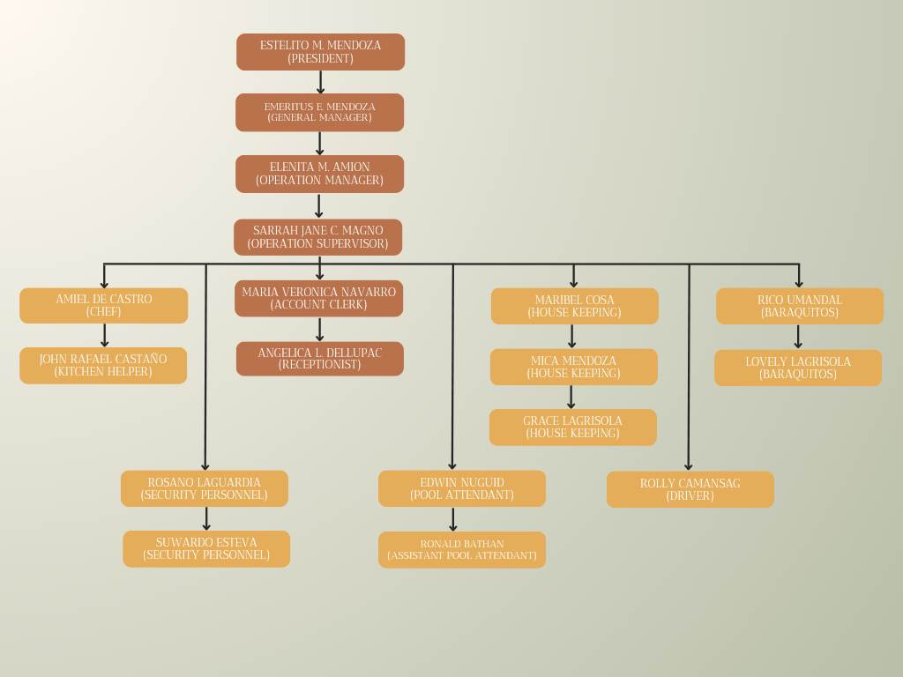

**DAY 3: Job Description**

**Task or Activity:** Be able to get the list of existing and available job or position in the company and enumerate its functions and responsibilities.

* Chef – he/she will cook for the order of the customers in Café.
* Kitchen Helper – he/she will help the chef to cook also.
* House Keeping – they will clean the bathroom and change bed sheet every day when guest are checking-in in the country club.
* Cashier – they are the person who will accepting order of café.
* Barista – they are the person who will providing the order of the customer.
* Driver – he is the driver of the supervisor, meanwhile he was cleaning all the garbage.
* Pool Attendant – they are the one who are cleaning the pool for the guest.
* Assistant Pool Attendant – they are the one who can help the Pool Attendant.
* Security Personnel – they are the one who will securing the country club.

**DAY 4: Workplace Environment**

**Task or Activity:** Be able to identify the different departments of the company including the offices and work areas and enumerate their functions and purposes.

* Baraquitos Café – this are the place that the customer can order food and coffee.
* Pavillion Main – this are the place that can book for any events to prepare their occasion.
* Hotel and Resort – this are the place that the guest can check-in and swim.
* Badmintton Court – this are the place that the player can perform their battle also can do such practices.
* Basketball Court – this are the place that the player can perform their battle also can do such practices.
* Office - this are the places were the transaction of the information perform.

**DAY 5: Weekly Diary**

**Task or Activity:** Write your personal thoughts, feelings and impression regarding your first week experience in doing work immersion.

The feelings of being worker will be very challenging. At first, I am very excited working because I feel happy when I am working neither at home. There such a nervous feeling for me because I didn’t expect that I can encounter different types of people. My impression of the job in their was doubted me that it is very hard to do but it is not. The work in their was enjoyable to do, not totally so hard.

**DAY 6: Employment Simulations**

**Task or Activity:** Be able to make a diagram regarding the company’s working procedure and explain its processes and pre-requisites.

**DAY 7: Work Ethics**

**Task or Activity:** Be able to identify the necessary attitudes and values needed to a certain work or area and write a concrete example on how to apply each value to a real scenario.

**DAY 8: Safety in the Workplace**

**Task or Activity:** Be able to familiarize with the working procedures and guidelines regarding work safety and security.

**DAY 9: Weekly Diary**

**Task or Activity:** Write your personal thoughts, feelings and impression regarding your first week experience in doing work immersion.

**DAY 10: Summary**

**Task or Activity:** Write a summary regarding all the task, duties, and responsibilities that we’re given to you during your 80-hours work immersion program.